PROJECT REPORT

**Project Name: AI-Powered Hourly Attendance System**

**C ONTENTS:**

## INTRODUCTION

* Overview
* Purpose

1. **LITERATURE SURVEY**

* Existing problem
* Proposed solution

1. **THEORETICAL ANALYSIS**

* Block diagram
* Hardware / Software designing

1. **EXPERIMENTAL INVESTIGATIONS**
2. **FLOWCHART**
3. **RESULT**
4. **ADVANTAGES & DISADVANTAGES**
5. **APPLICATIONS**
6. **CONCLUSION**
7. **FUTURE SCOPE**
8. **BIBLIOGRAPHY**

* **APPENDIX**

1. **Source code**
2. **INTRODUCTION**

### OVERVIEW:

The Attendance Monitoring System is essential in all organizations for checking the performance of students and it is not an easy task to check each and every student is present or not. In all organization attendance are taken manually by calling their register numbers or names and noted in attendance registers issued by the department heads as a proof and in some organizations the students want to sign in these sheets which are stored for future references. This technique is repetitive, complex work and leads to errors as few students regularly sign for their absent students or tell proxy attendance of the absent students. This method additionally makes it more complex to track all the students attendance and difficult to monitor the individual student attendance in a big classroom atmosphere. In this we use are using the technique of utilization face detection and recognition framework to continuously recognize students going to class or not and marking their attendance by comparing their faces with a database to match and marking attendance. This facial biometric framework takes a picture of a person using camera and contrasts that image and compares the image with the image which is stored at the time of enrolment and if it matches marks the attendance and monitor the student performance continuously. We may use the concept of artificial intelligence concept to monitor student attendance like capturing the motion pictures of the student when present in class to analyze the student data how much time the student presents in class.

### PURPOSE:

The purpose of this project is to automate the attendance system to decrease the errors that occur due to the manual taking attendance. If the cameras monitoring into classrooms to evaluate their interest and to mark attendance, students tends to pay attention if Artificial Intelligence enabled method can monitor and mark their attendance and faculties will at least come to school or college every day because, in early times they are coming and putting sign and they are letting the school or college now

it’s not possible if the faculty left the college the system automatically marks as absent so everyone will come to school or organization regularly.

# LITERATURE SURVEY

### EXISTING PROBLEM:

Maintaining attendance is very important in all the institutes for checking the attendance percentage of Students. Every institute has its own method in this regard. Some are taking attendance manually on the register for every hour and later they will upload every hour data of a class to the server or file-based approach and some have adopted methods of automatic attendance using some biometric techniques. But these methods are inefficient and time-consuming, AI can definitely find a solution to this problem.

**PROPOSED SOLUTION:**

The proposed solution/application shall capture hourly attendance without any manual intervention. develop a smart device that can be integrated with a camera that will capture the images of class for every hour and send the images to model. Then the model will use AWS Rekognition Service to recognize the student’s faces & push the images to S3(Simple Storage Service) for storage and also updates the attendance automatically in a database. build a web-based dashboard to visualize all the student’s attendance information.

# THEORETICAL ANALYSIS

## BLOCK DIAGRAM:

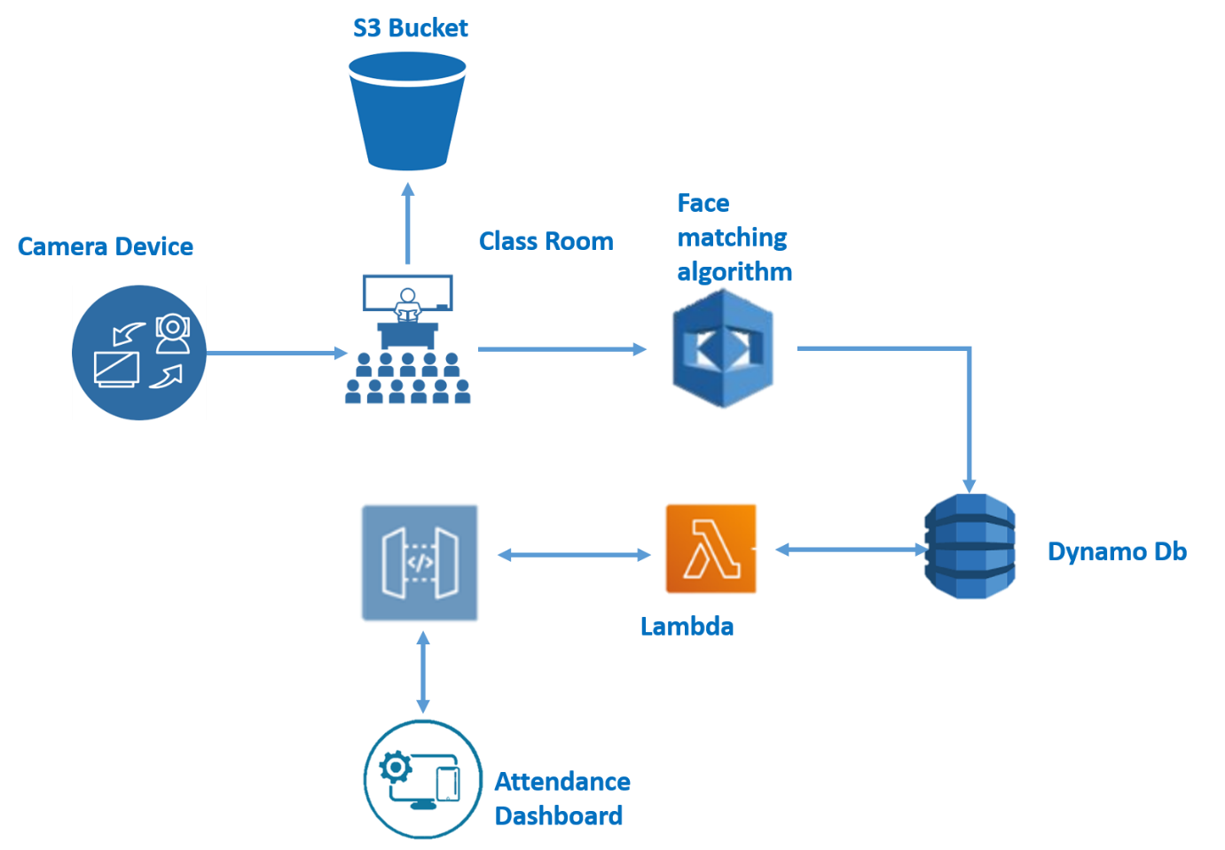

**SOFTWARE DESIGNING:**

* Storing the Images of Students in S3 Bucket
* Capturing the image on an Hourly basis
* Loading the image to Face comparison algorithm (compares the faces in s3 bucket)
* Marking the attendance for compared faces and storing in DynamoDb
* Creating a rest API using API gateway and lambda function to connect to dynamo DB through web app
* Creating a web-based dashboard to visualize the attendance

# EXPERIMENTAL INVESTIGATION

### Python Web Frameworks:

A Web framework is a collection of packages or modules which allow developers to write Web applications (see [WebApplications](https://wiki.python.org/moin/WebApplications)) or services without having to handle such low-level details as protocols, sockets or process/thread management. A web application may use a combination of a base HTTP application server, a storage mechanism such as a database, a template engine, a request dispatcher, an authentication module and an AJAX toolkit. These can be individual components or be provided together in a high-level framework. The most popular high-level frameworks are [Django,](https://www.djangoproject.com/)[TurboGears](https://www.turbogears.org/),[web2py](https://www.web2py.com/) etc.

### AWS DynamoDB:

Amazon DynamoDB is a NoSQL database that supports key-value and document data models, and enables developers to build modern, serverless applications that can start small and scale globally to support petabytes of data and tens of millions of read and write requests per second. DynamoDB is designed to run high-performance, internet-scale applications that would overburden traditional relational databases.Amazon DynamoDB is a key-value and document database that delivers single-digit millisecond performance at any scale. It's a fully managed, multiregion, multimaster, durable database with built-in security, backup and restore, and in-memory caching for internet-scale applications

**AWS Rekognition:**

Amazon Rekognition makes it easy to add image and video analysis to your applications using proven, highly scalable, deep learning technology that requires no machine learning expertise to use. With Amazon Rekognition, you can identify objects, people, text, scenes, and activities in images and videos, as well as detect any inappropriate content. Amazon Rekognition also provides highly accurate facial analysis and facial search capabilities that you can use to detect, analyze, and compare faces for a wide variety of user verification, people counting, and public safety use cases.

## Amazon S3:

Amazon Simple Storage Service (Amazon S3) is an object storage service that offers industry-leading scalability, data availability, security, and performance. This means customers of all sizes and industries can use it to store and protect any amount of data for a range of use cases, such as websites, mobile applications, backup and restore, archive, enterprise applications, IoT devices, and big data analytics. Amazon S3 provides easy-to-use management features so you can organize your data and configure finely-tuned access controls to meet your specific business, organizational, and compliance requirements.

## AWS API Gateway:

Amazon API Gateway is a fully managed service that makes it easy for developers to create, publish, maintain, monitor, and secure APIs at any scale. APIs act as the "front door" for applications to access data, business logic, or functionality from your backend services. Using API Gateway, you can create RESTful APIs and WebSocket APIs that enable real-time two-way

communication applications. API Gateway supports containerized and serverless workloads, as well as web applications.

API Gateway handles all the tasks involved in accepting and processing up to hundreds of thousands of concurrent API calls, including traffic management, CORS support, authorization and access control, throttling, monitoring, and API version management. API Gateway has no minimum fees or startup costs. You pay for the API calls you receive and the amount of data transferred out and, with the API Gateway tiered pricing model, you can reduce your cost as your API usage scales.

## AWS Lambda:

AWS Lambda lets you run code without provisioning or managing servers. With Lambda, you can run code for virtually any type of application or backend service - all with zero administration. Just upload your code and Lambda takes care of everything required to run and scale your code with high availability. You can set up your code to automatically trigger from other AWS services or call it directly from any web or mobile app.

# FLOWCHART

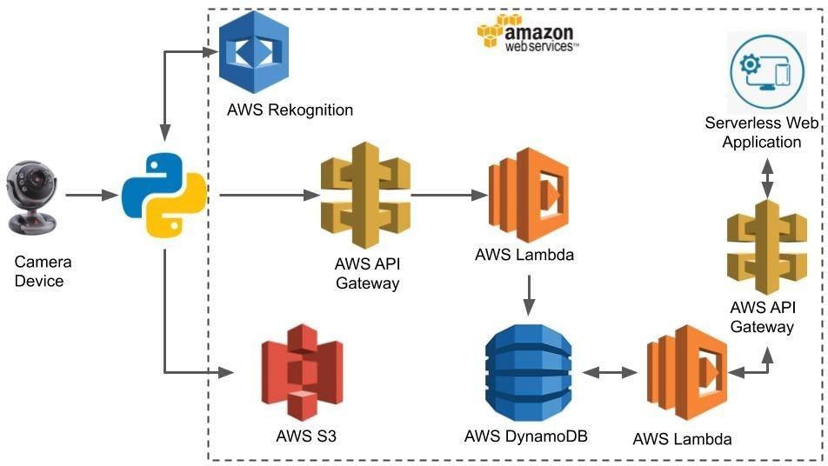

1. **RESULT:**

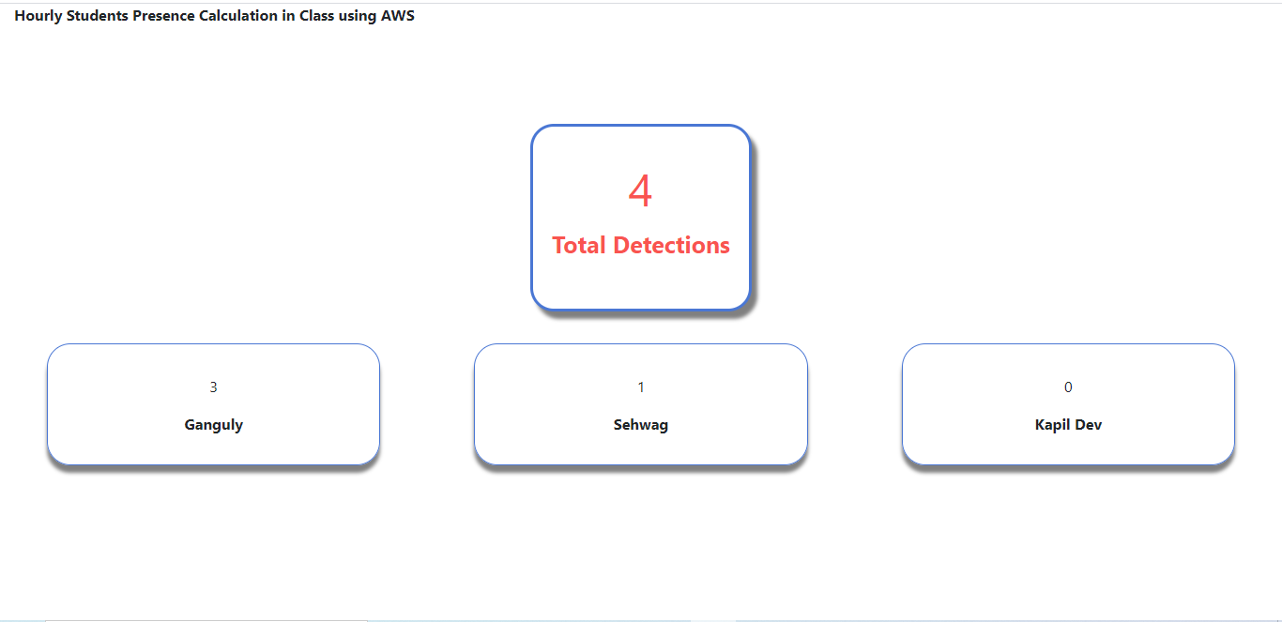

1. **ADVANTAGES AND DISADVANTAGES:**

* ADVANTAGES:
  + Cost-effective
  + Increased security
  + Time saving
  + Easy to manage
  + Automated time tracking system
* DISADVANTAGES:
  + Data privacy breach
  + Low reliability

# APPLICATIONS:

* Contactless [biometric attendance system](https://www.pockethrms.com/biometric-attendance-system/) in educational institutes and offices
* Airport security increases
* In Warehouse**,** Control process to provision entry and exit of vehicles

# CONCLUSION:

We are automating the attendance system to decrease the errors that occur due to the manual taking attendance. If the cameras monitoring into classrooms to evaluate their interest and to mark attendance, students tends to pay attention if Artificial Intelligence enabled method can monitor and mark their attendance and faculties will at least come to school or college every day because, in early times they are coming and putting sign and they are letting the school or college now it’s not possible if the faculty left the college the system

automatically marks as absent so everyone will come to school or organization regularly. Using the artificial intelligence concept the attendance monitoring system is very secure, accurate and easy to monitor students and faculty’s attendance.

# FUTURE SCOPE:

The world is using facial recognition technology and enjoying its benefits.The technology and its applications can be applied across different segments in the country.

* Preventing the frauds at ATMs in India. A database of all customers with ATM cards in India can be created and facial recognition systems can be installed. So, whenever a user enters an ATM his photograph will be taken to permit access after it is matched with a stored photo from the database.
* Reporting duplicate voters in India.
* Passport and visa verification can also be done using this technology.
* Also, driving license verification can be done using the same approach.
* In the defence ministry, airports, and all other important places the technology can be used to ensure better surveillance and security.
* It can also be used during examinations such as Civil Services Exam, SSC, IIT, MBBS, and others to identify the candidates.
* This system can be deployed for verification and attendance tracking at various government offices and corporates.
* For access control verification and identification of authentic users it can also be installed in bank lockers and vaults.
* For identification of criminals the system can be used by the police force also.

# BIBLIOGRAPHY:

Son, N.T.; Chi, L.P.; Lam, P.T.; Van Dinh, T. Combination of facial recognition and interaction with academic portals in automatic attendance systems. In Proceedings of the 2019 8th International Conference on Software and Computer Applications (ICSCA ’19). ACM, New York, NY, USA, 19–21 February 2019; pp. 299–305

# APPENDIX:

Source code:

<https://github.com/Likhitha5l7/AI-Powered-Hourly-Attendance-System>

Team Members:

# 1.Sonagiri Likhitha (17RH1A05L7)

# 2. Thandra Preethi (17RH1A05M3)

# 3. Yellala Anusha (13RH1A05P0)